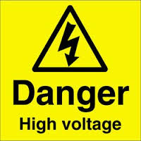
Danger
High Voltage Tests
RPC RE-4
Tel; Anton 162692
Tel; Ian 164414

